## Problem 1 – Watch Store

Create a Web page (HTML5 + CSS3 + images) that looks and behaves like the screenshots below:

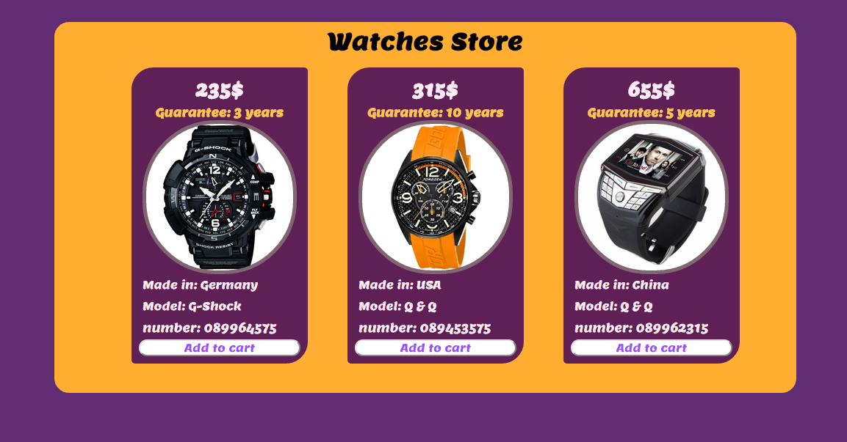

### Input

You are given the above screenshots + all required images + the texts on the site.

### Output

The output should be valid HTML5 + CSS3 + images that implement the above Web page.

### Constraints

* Font: Lemon-Regular / Arial
* Font size: **24px** for the main title, **22px** for price of watches, **15px** for info of the watches, **15px** for the buttons.
* Container width: 1000px.
* Watches container width: 900px.
* Columns width: 220px.
* Spacing between columns: 20px.
* The site should open correctly in Chrome 35.
* Responsive design is not required.
* Pixel-perfect implementation is not required.